**Remote Deposit System (RDS) Manual**

**Outline of Procedures**

Day 1 Evening

* Receive and verify checks, fill in checklist, stamp reports, email copies of BofA checks +200k to county Treasurer, store in locked cabinet

Day 2 Morning

* Process checks into BofA CashPro, Send email of previous days’ deposit to SFS Accounting Group
* *Due to pandemic, the processing of school deposits is done twice a week.

Trouble Shooting Common Errors

* Common issues and back up procedures

**Day 1 Evening**

1. School Districts send checks and corresponding Deposit Report(s) to Revenue & Apportionment (R&A) via jet bag daily. Mail is received around mid-afternoon daily. The cut-off time is 3:30pm.
2. DP Accountant and/or the JV Accountant opens the mail and stamps date and time received on each DP. The reports are then sorted by district in alphabetical order.
3. Verify if checks are eligible for deposit. DPs with checks which are not in compliance with LACOE Bulletins will be set aside and put on hold. Please refer to LACOE Informational Bulletin #342 dated March 23, 2005, Bulletin #315 dated April 21, 2010 and Bulletin #92 dated October 31, 2011 for proper district deposit procedures.
4. Each district should have a clearing account, which is a commercial bank account in the district’s name for check clearing or cash deposit purposes. This account is established and operated in accordance with district policies. Please note that neither SFS nor the Treasury will accept cash under any circumstances.

*Amounts less than 10,000*

*All cash, cashier’s checks, money orders, personal or corporate checks, and warrants with an amount less than $10,000, should be deposited into the clearing account. A check from this account covering the cash and items under $10,000 should be sent to SFS for deposit into the Treasury.*

*Amounts over $10,000*

*Cashier’s checks, money order, warrants and private checks received by the organizations listed above that exceed $10,000 may be sent directly to SFS to be deposited into the Treasury.*

1. List and match each district’s total checks with the attached LAGL reports. Journal date on the LAGL report should match or be later than the district’s clearing account check date. The dollar amount written on the check should match the check numerical amount. Each LAGL 7501 report should also have district’s preparer’s information.
2. Deposits that are not in compliance with LACOE Bulletins are set aside, and put on hold. Next morning the DP Accountant will email District to ask them to correct the error, or request the district’s assigned Accounting Technician to contact the districts themselves and assist the districts in correcting the errors.

Examples of common district mistakes include but are not limited to the following:

1. Journal Date is earlier than the Clearing Account Check Date.
2. Missing Preparer’s information
3. Wrong written dollar amount
4. Missing Signature
5. Missing reports
6. Missing Record Date
7. Below is a sample copy of LAGL 7501 report received from the district.

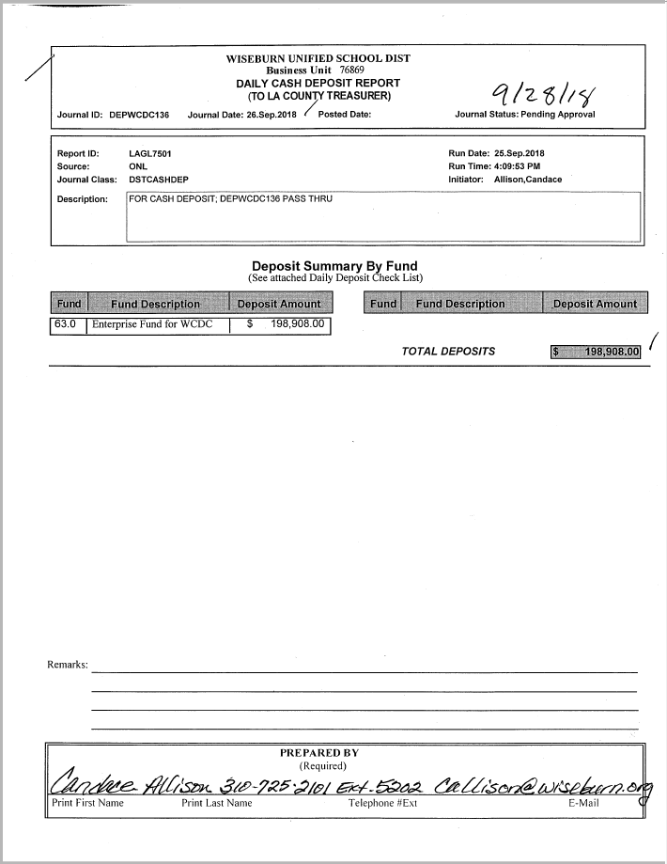  
**OR**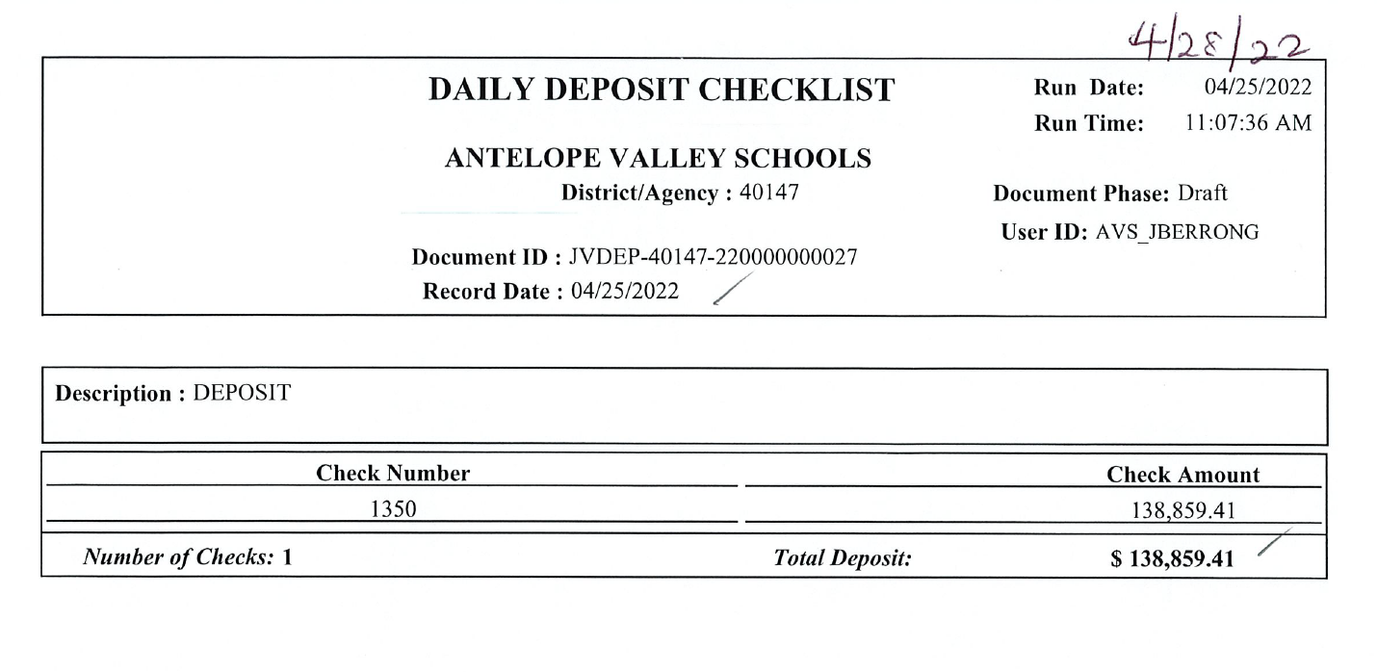

1. The deposits that are in compliance with LACOE Bulletins are entered in the Daily Deposit Log. Open the School Deposit Log [S:\School Deposits\FY2122\School Deposit-Tech-FY21-22 Template.xls](../../School%20Deposits/FY1819/School%20Deposit-Tech-FY18-19%20-%20Template.xls). Save the file under a new file name School Deposit Tech FYxx-xx – Deposit Date (Example: School Deposit-FY21-22 - 2022.06.23 PSFS)

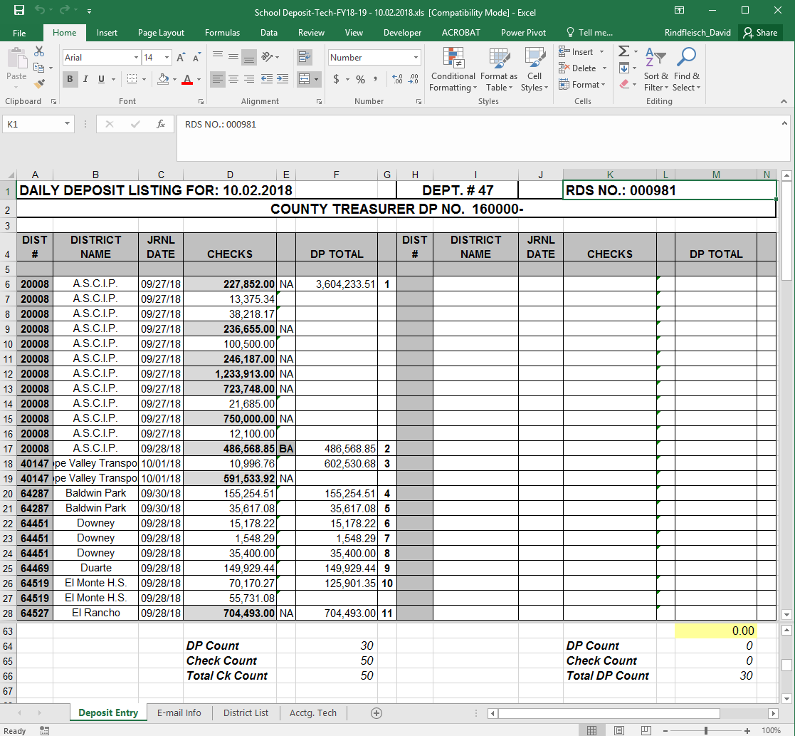

1. Deposit information to be entered include, District number, Journal Date, Check amount, deposit amount.
2. A built in control total within the spreadsheet is utilized to ensure that the total of actual checks matches the total per LAGL Report. The control total should remain zero (0) which indicates that the total actual checks equal the district GL.
3. Manually count the checks and matches it with the total check count on the worksheet. Then separate the district LAGL Report and checks.
4. For all the checks that are greater than $200,000 and from Bank of America scan check(s) and email to TTC-CashOps <cashops@ttc.lacounty.gov> at the LA County Auditor Controls office.
5. **Email Tittle: LACOE SFS Deposit for 2022-XX-XX - BOA Checks over $200K.**
6. **Save the email copy in the FYXXXX BOA CKs Notification folder**
   1. **Folder pathway: \\Sfs_server\sfs_division\ACCOUNTING\USERS\SFS AR Section\School Deposits\FYXXX**
7. Place the checks in an envelope and the paperwork in the blue folder marked School Deposits
8. List the following on the outside of the envelope to be completed the next day after the checks have been scanned into the CashPro

* Deposit Date
* # of checks
* Deposit #
* Prepared by

1. Place the Deposit Folder inside a locked drawer for review by the Principal Accountant or Senior Accountant the following day. Following are placed inside the Deposit Folder:

* Checks (No endorsement is needed with the RDS Scanner since it is digitally endorsed)
* School Districts LAGL 7501 & 7502 Reports
* Daily Deposit Listing Spreadsheet
* Email of BofA checks over $200,000 (see # 12) if there is any.

**Day 2 Morning**

1. The Principal Accountant or Senior Accountant verifies that all checks are in accordance with LACOE Bulletins, makes sure that the count and amount matches the Deposit Sub Stub, verifies that checks over $200,000.00 from Bank of America have been emailed, and then initials the Daily Deposit Listing Spreadsheet.
2. Log into CashPro
3. Hover over “Receipts” ribbon on the top of the page and click “Remote Deposit”

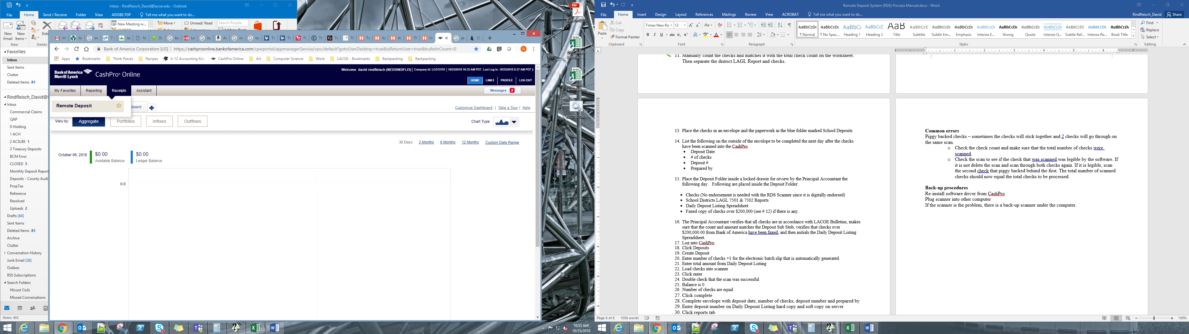

1. On the next page click “Create new deposit”

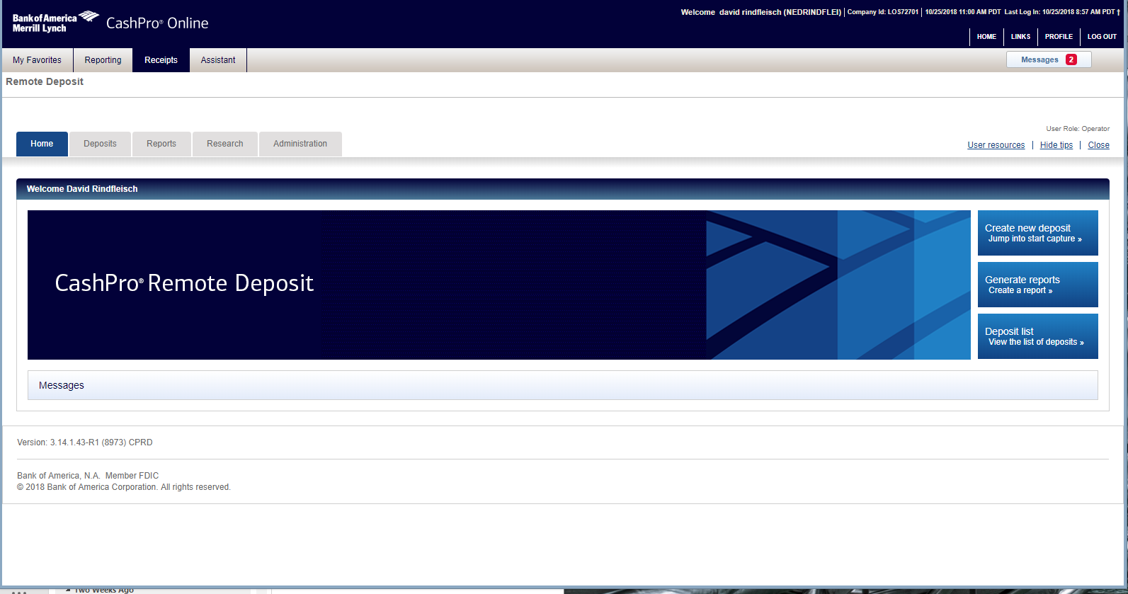

1. Select the correct “Account number” from the dropdown option:
2. Enter number of checks +1 for the electronic batch slip that is automatically generated.
   1. For example, if there are 10 checks, enter 11 (10+1) in the “Number of items”.
3. Select “Start Capture” button.
4. .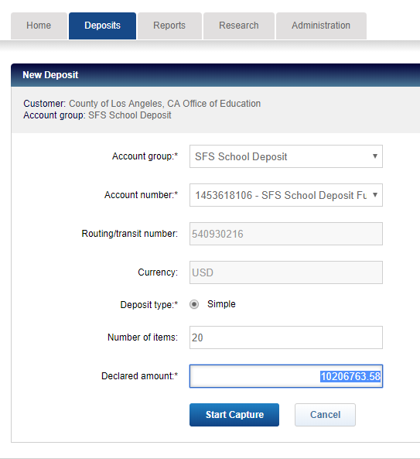
5. Once the checks are scanned click through the pages and correct any items highlighted in red
   1. Edit/confirm the amounts by clicking the edit button on the left hand side

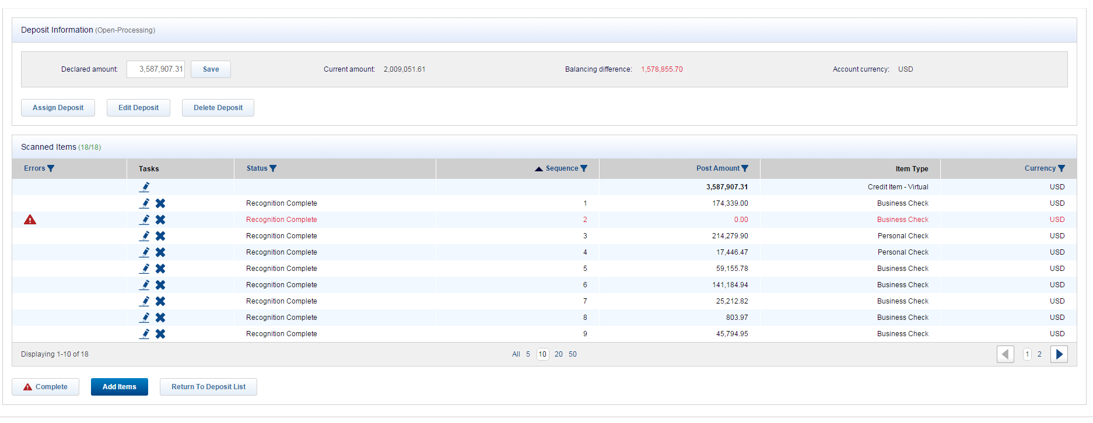

1. Once clicked a dialog box will pop-up with the check image and edit fields
   1. You can edit/add the amount in the “Amount” field
   2. Click “Save” when you are done

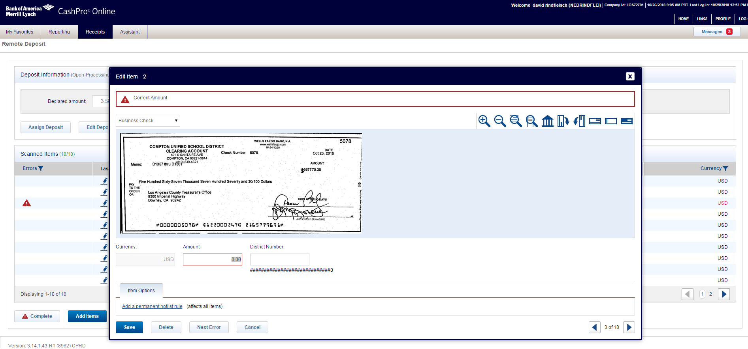

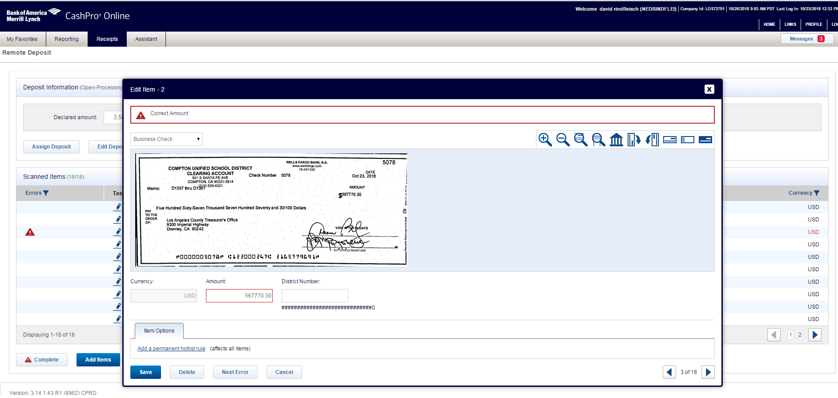

1. Place checks in tray with the front of the checks facing outward. Click “Start Capture”
2. Double check that the scan was successful
3. Balance is 0
4. Number of checks are equal
5. Click complete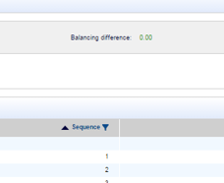

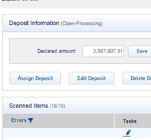

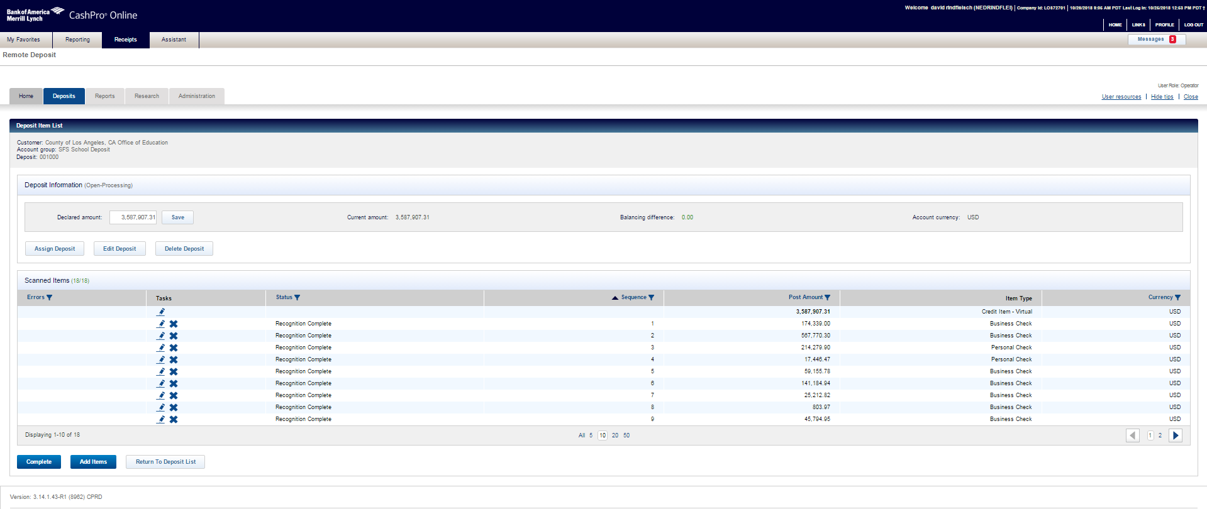

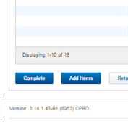

1. After you click complete a dialog box will pop-up asking you to confirm click “OK”

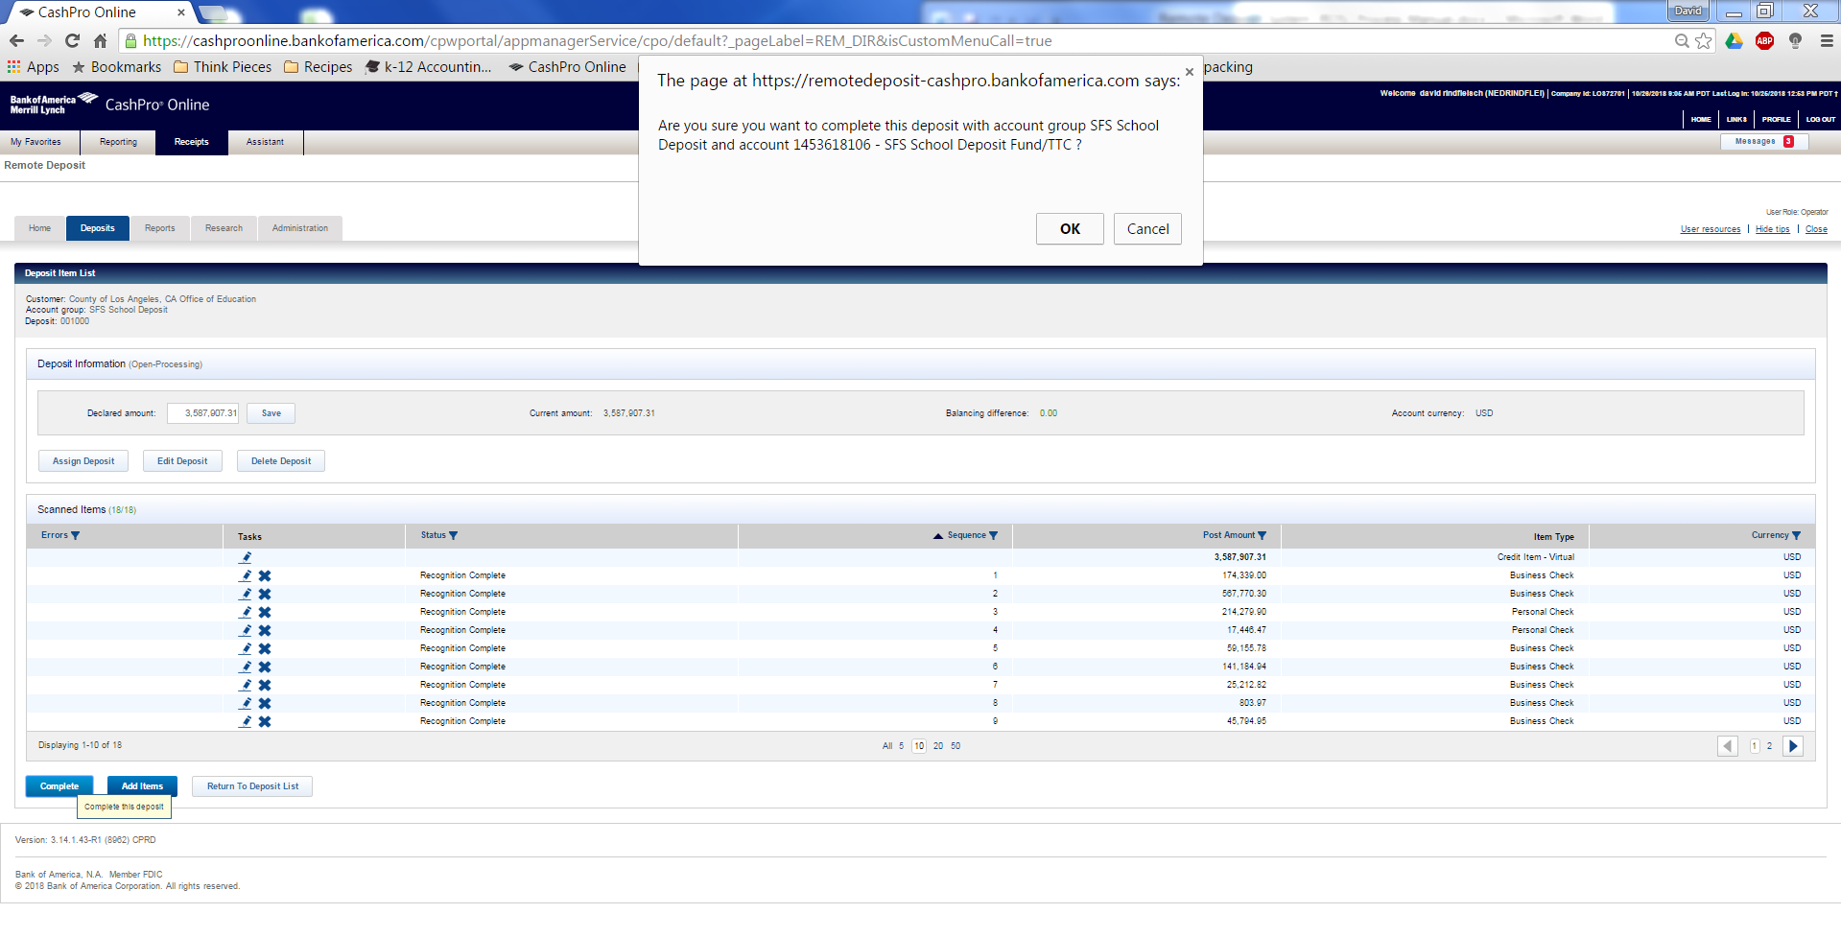

1. Record the Deposit Number on the daily Deposit Listing hard copy and soft copy on the server
   1. You can find the Deposit Number in “List of Deposit” which will be the next page after you confirm the deposit

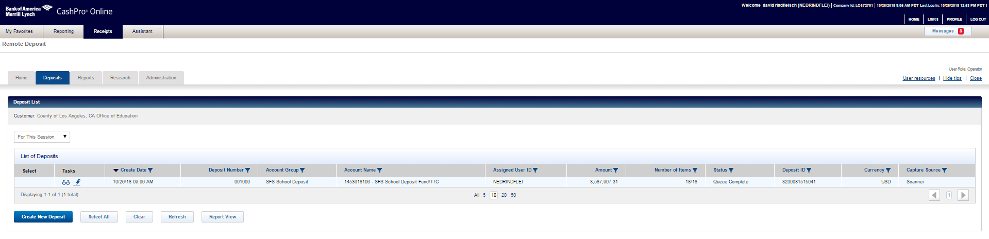

1. Complete envelope with deposit date, number of checks, deposit number and prepared by

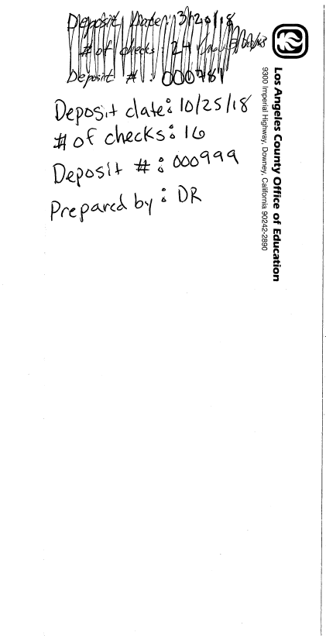

Next, click “Reports” tab

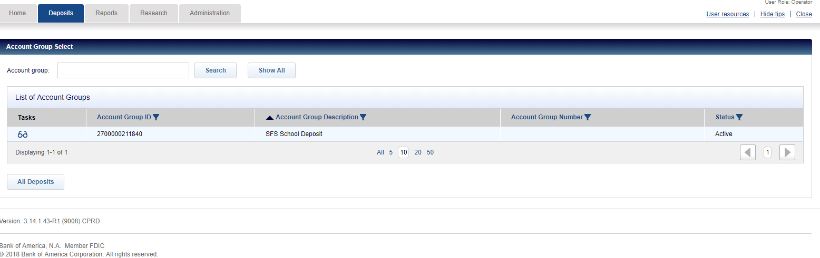

1. Select deposit report by deposit number

* Report = “Deposit Details by Deposit Number”,
* Format = “PDF”,
* Deposit number = (Deposit number from the deposit you just generated)
* Images = “BW images”,
* Click “Create Report”

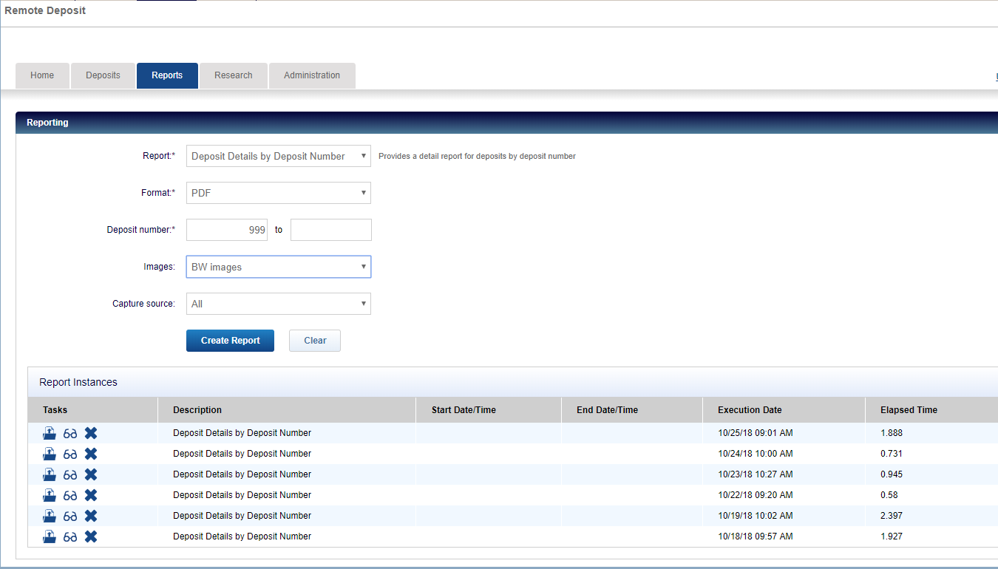

1. The report will generate in “Report Instances” in the area below in a few seconds
2. Once the report is finished generating click the download button to the left of the new report

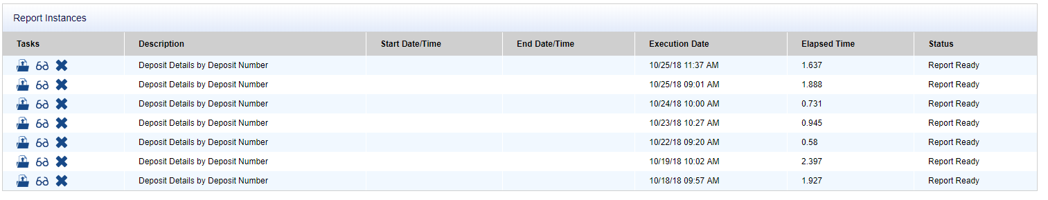

1. The report will be downloaded and will pop up at the bottom of your browser. Click into the report

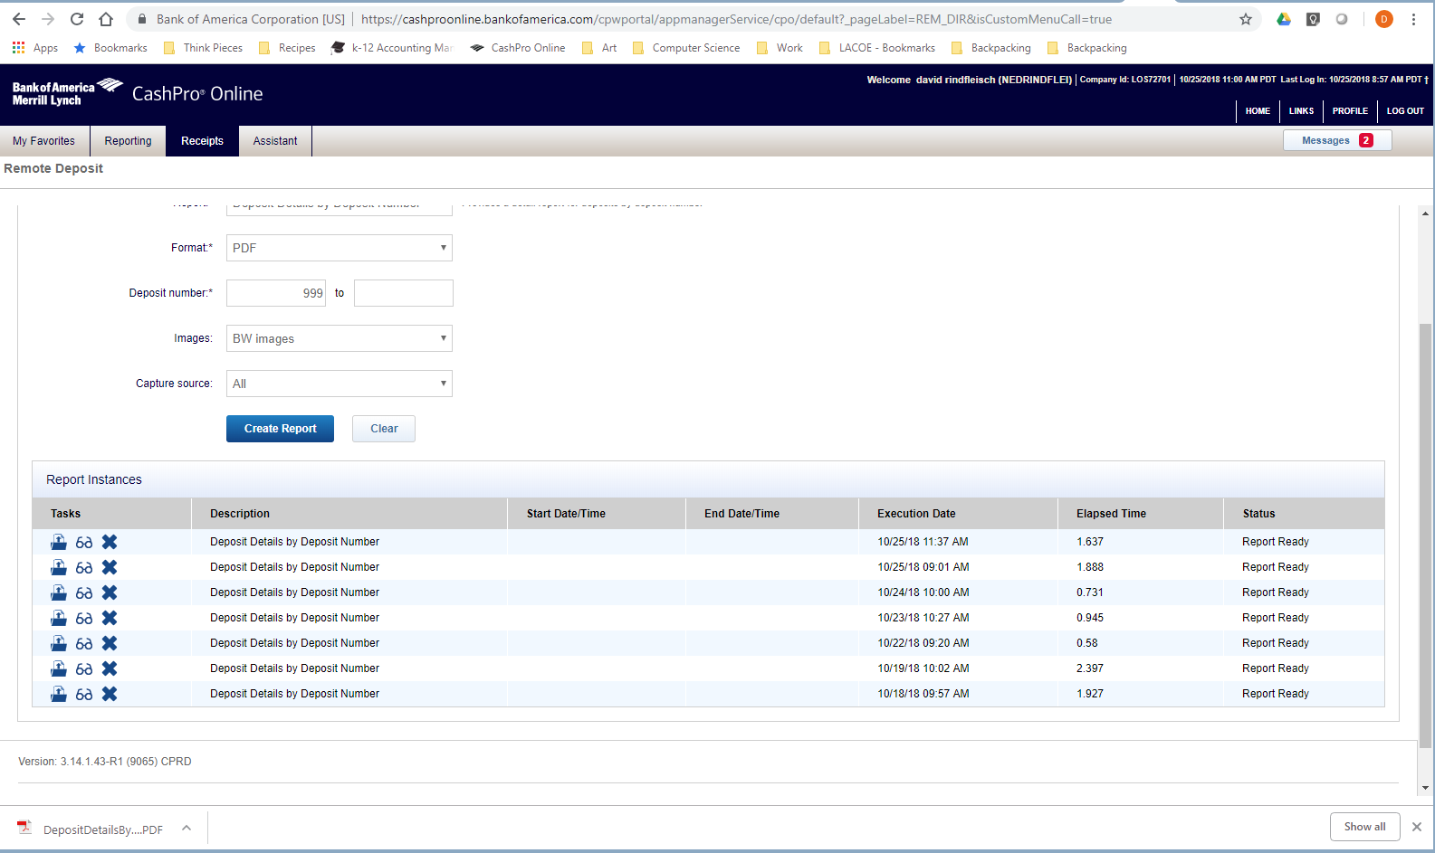

1. Save the entire report to the server at \\Sfs_Server\SFS_DIVISION\ACCOUNTING\USERS\SFS AR Section\School Deposits\FYXXXX

and into the folder of the current fiscal month followed by “Remote Dep Ck List” the file should have the deposit date in the name

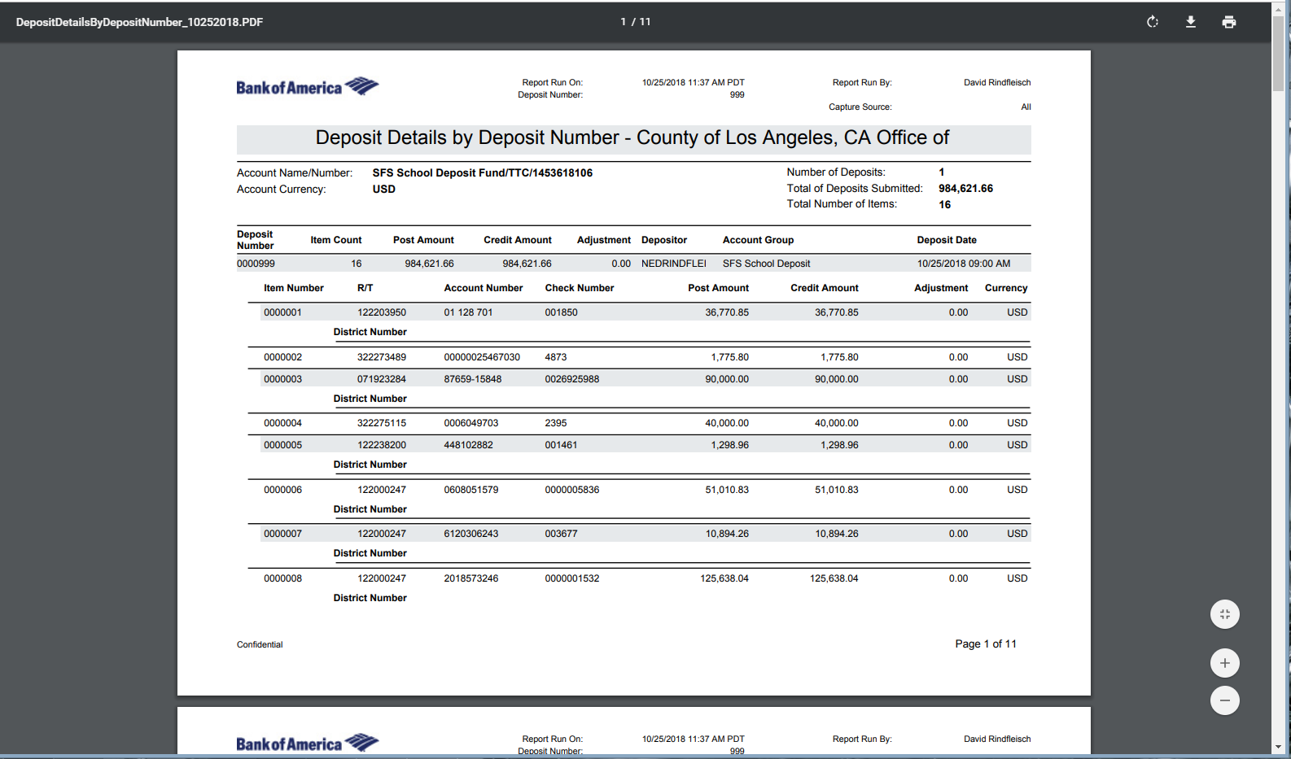

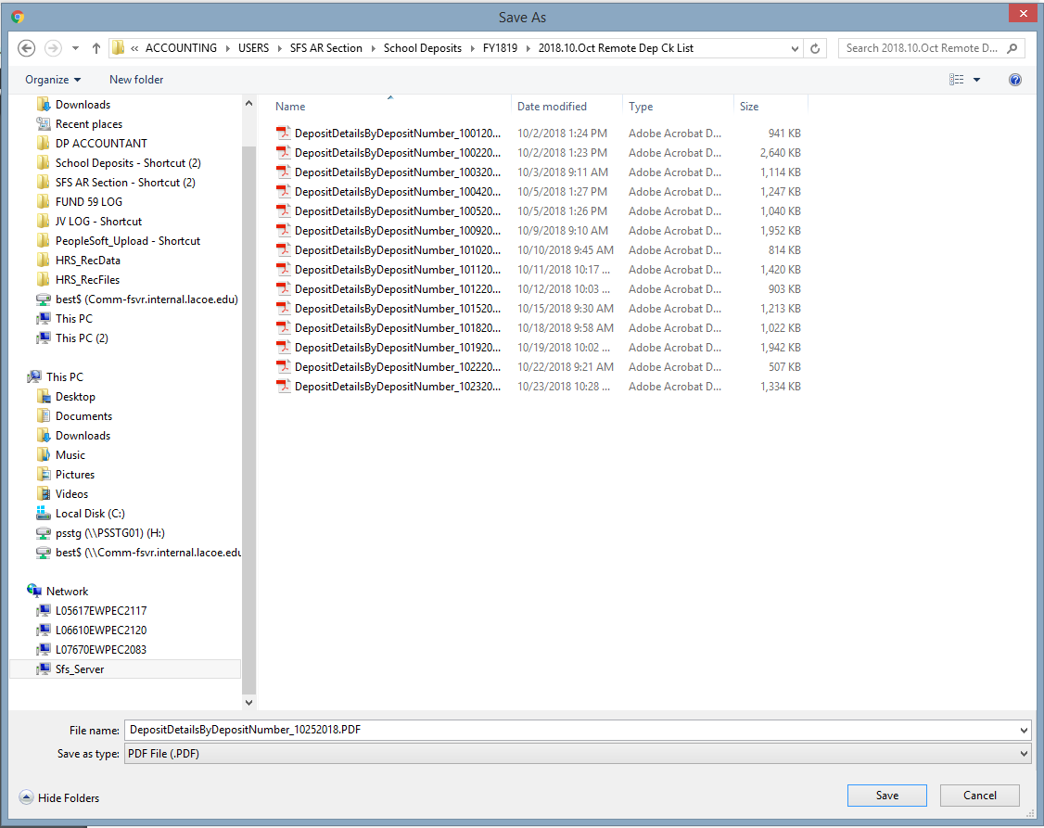

1. After everything has been printed, saved and recorded. Place the envelope with the checks inside into the file cabinet and lock it until after lunch when we pull the proof of deposit (perfected report)
2. At around 1:15pm log back into BOA CashPro and pull the Perfected report that is proof of your deposit.
3. Log into CashPro
4. Hover over “Receipts” ribbon on the top of the page and click “Remote Deposit”



1. Click on “Deposit list”

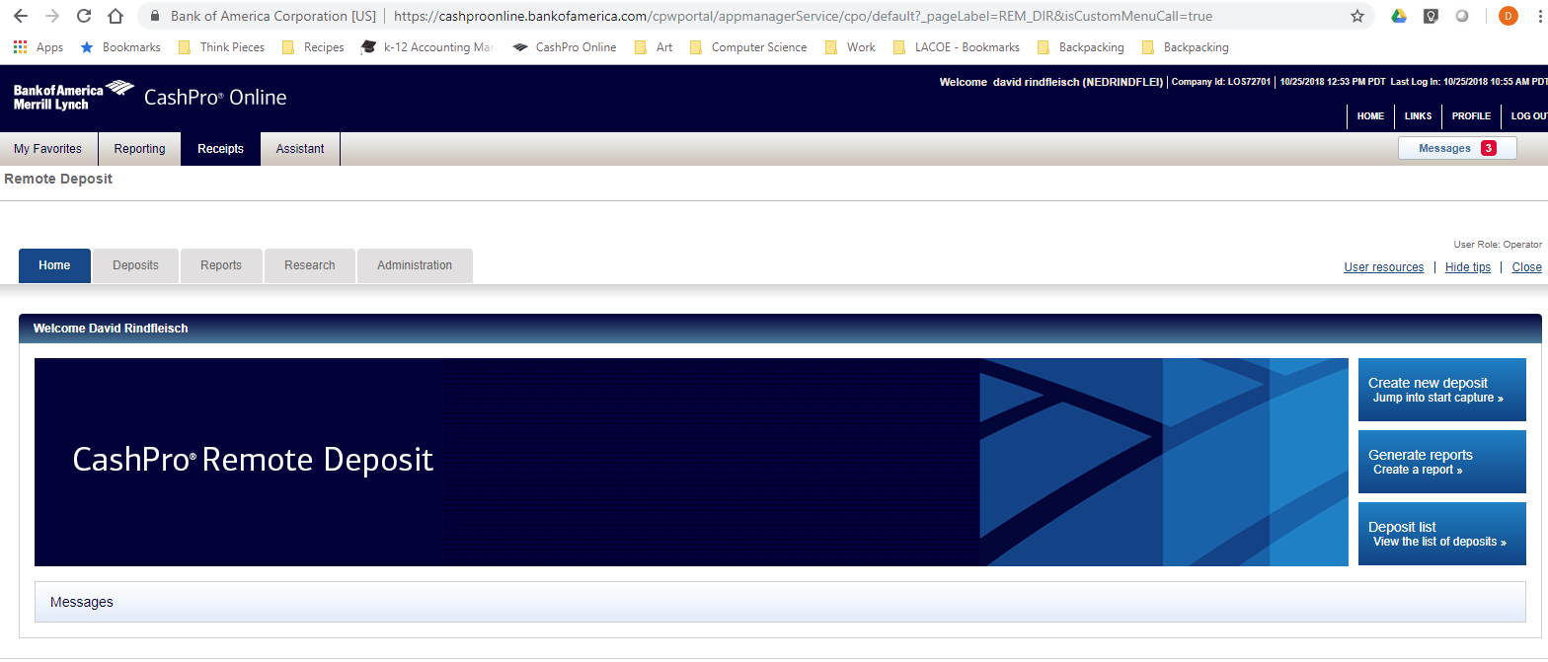

1. On the next page click the line with the account #2700000211840

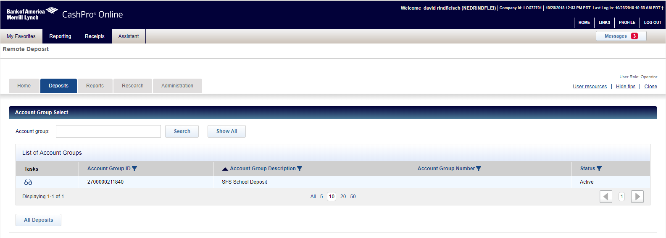

1. In the dropdown select for today to find the deposit you processed earlier

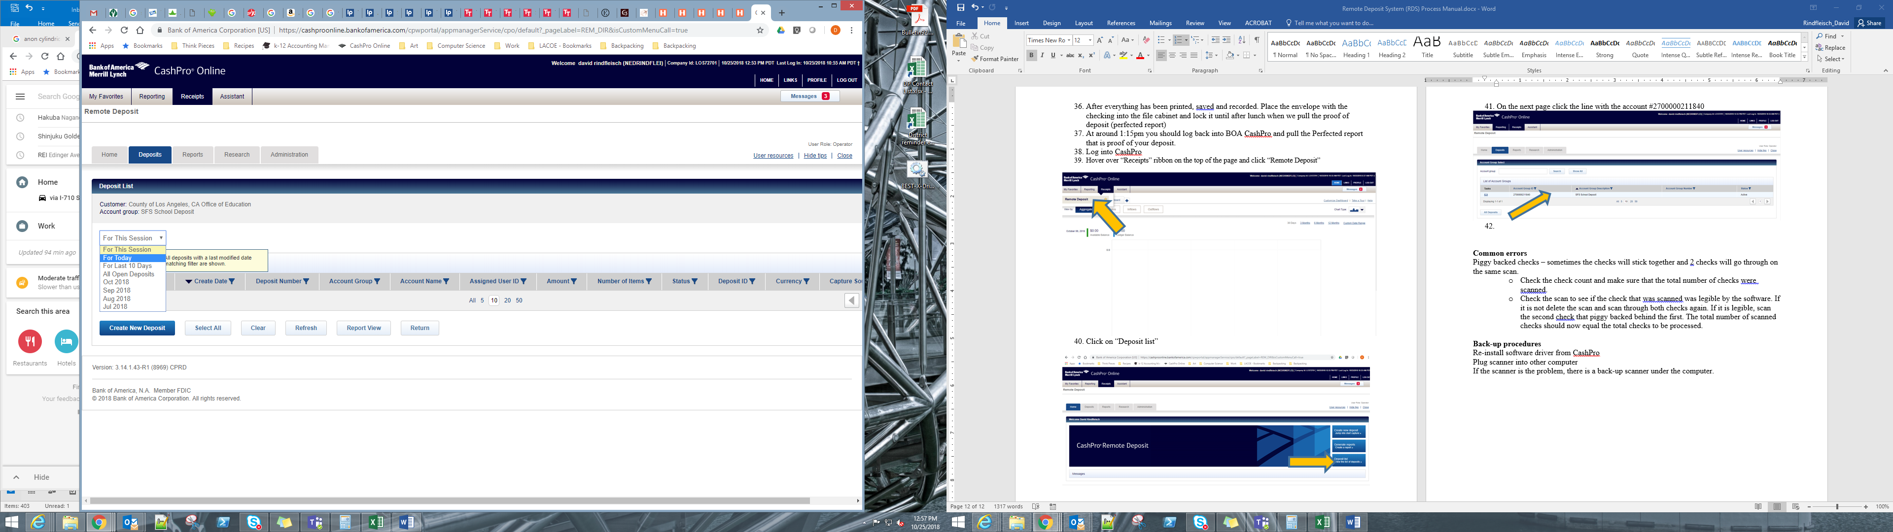

1. This morning’s deposit will appear. Verify that the status is “Perfected”

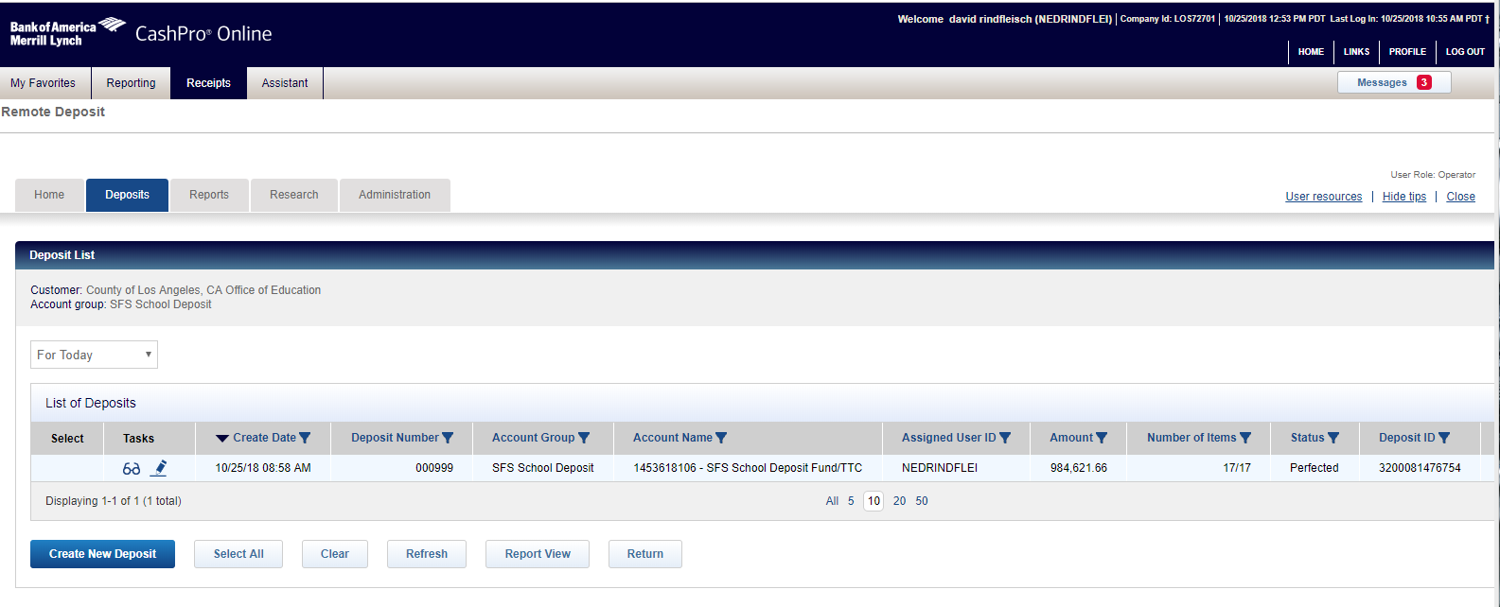

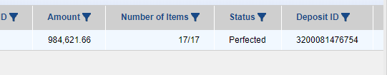

1. Click “Report View and print 1 copy and save another copy as PDF in the folder. The printed copy will go in the envelope with the checks.



1. The envelope with the checks, check list from CashPro and Copy of Perfected report should be placed in the safe.
2. The deposit process is now complete. Sit back, ponder the meaning of life and have an existential crisis thinking about the vast expanse of the universe
   1. Questions to consider:
      1. If there are 200 billion stars in our galaxy and 200 billion galaxies in the observable universe, by shear probability must there be other life in the universe?
      2. If a 98 pound girl eats a 2 pound burrito, is she 2% burrito?
      3. A duck’s quack doesn’t echo.
      4. What is up with that?

**Trouble Shooting Common Errors**

Piggy backed checks

Sometimes the checks will stick together and 2 checks will go through on the same scan.

* Confirm the check count and make sure that the total number of checks were scanned.
* Make sure you added one to the number of checks to account for the digital deposit slip
* Check the scan to see if the check that was scanned was legible by the software. If it is not delete the scan and scan through both checks again. If it is legible, scan the second check, that piggy backed behind the first. The total number of scanned checks should now equal the total checks to be processed.

Check amount does not match entered amount

* Sometimes the check scanner will miss read the amount on the check and submit a different amount into CashPro without indicating an error
* The most common instance is when the check scanner will miss a 1 in the beginning of the amount on the check
* To identify the discrepancy, double check that you entered the correct amount into CashPro
* If the amount was entered correctly, compare the Daily Cash Deposit Listing to the CashPro items line by line to find the discrepancy
* Once identified, use the edit feature to correct the amount. Make sure to double check the check image for the new amount you are entering

**Back-Up Procedures**

Re-installing the scanner’s software driver from CashPro

Steps for re-installing driver

1. From the Home Screen go to Receipts -> Remote Deposit



1. Click “User resources” on the right side of the screen

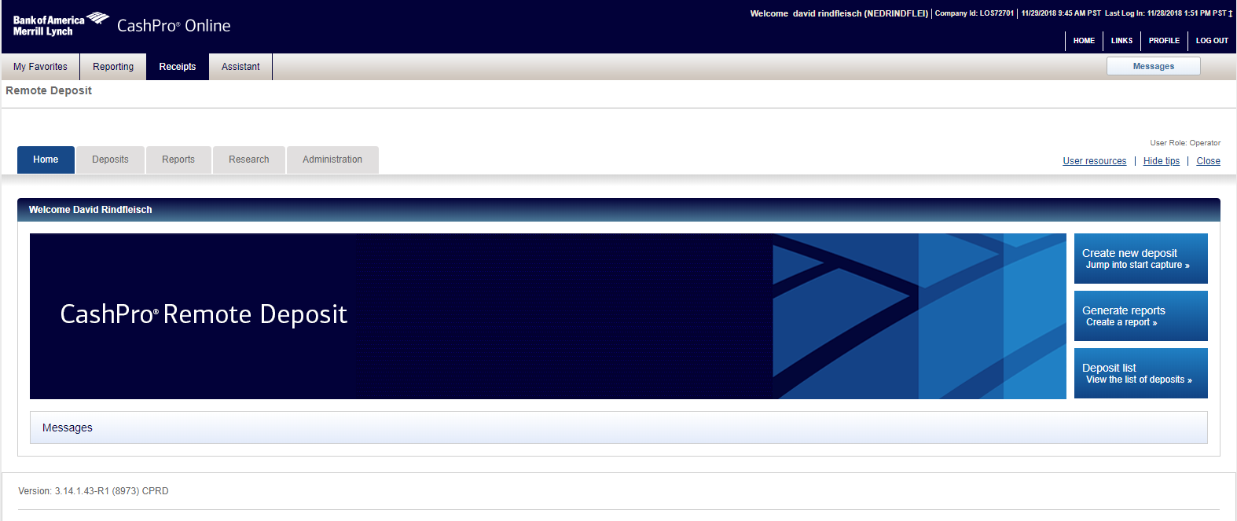

1. A pop-up window will appear Click “Scanner Driver Download Page”

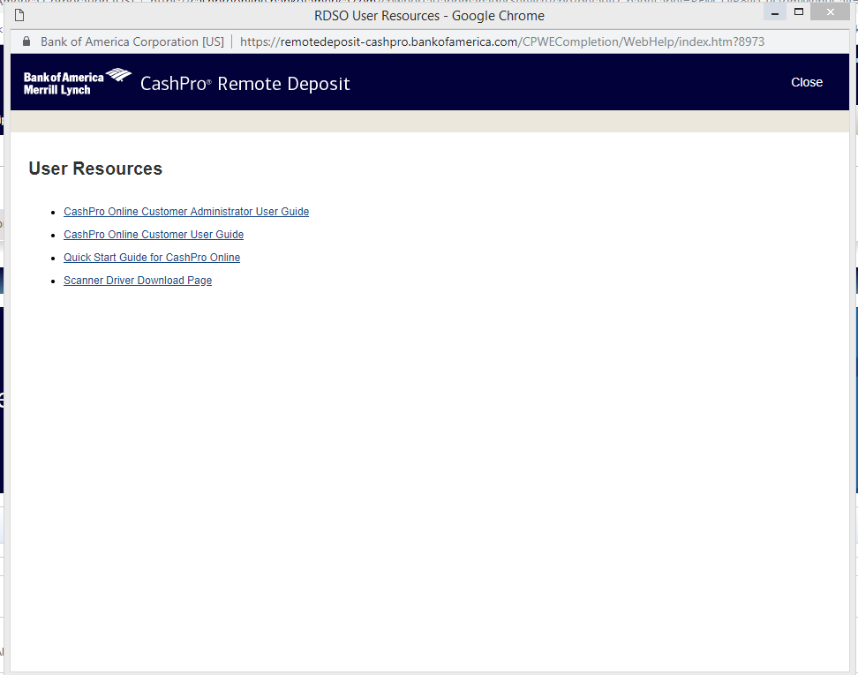

1. Select the large “Digital Check” button
2. The driver installation exe file named “DigitalCheck.exe” will appear at the bottom of the window
3. Click the file to open the installation

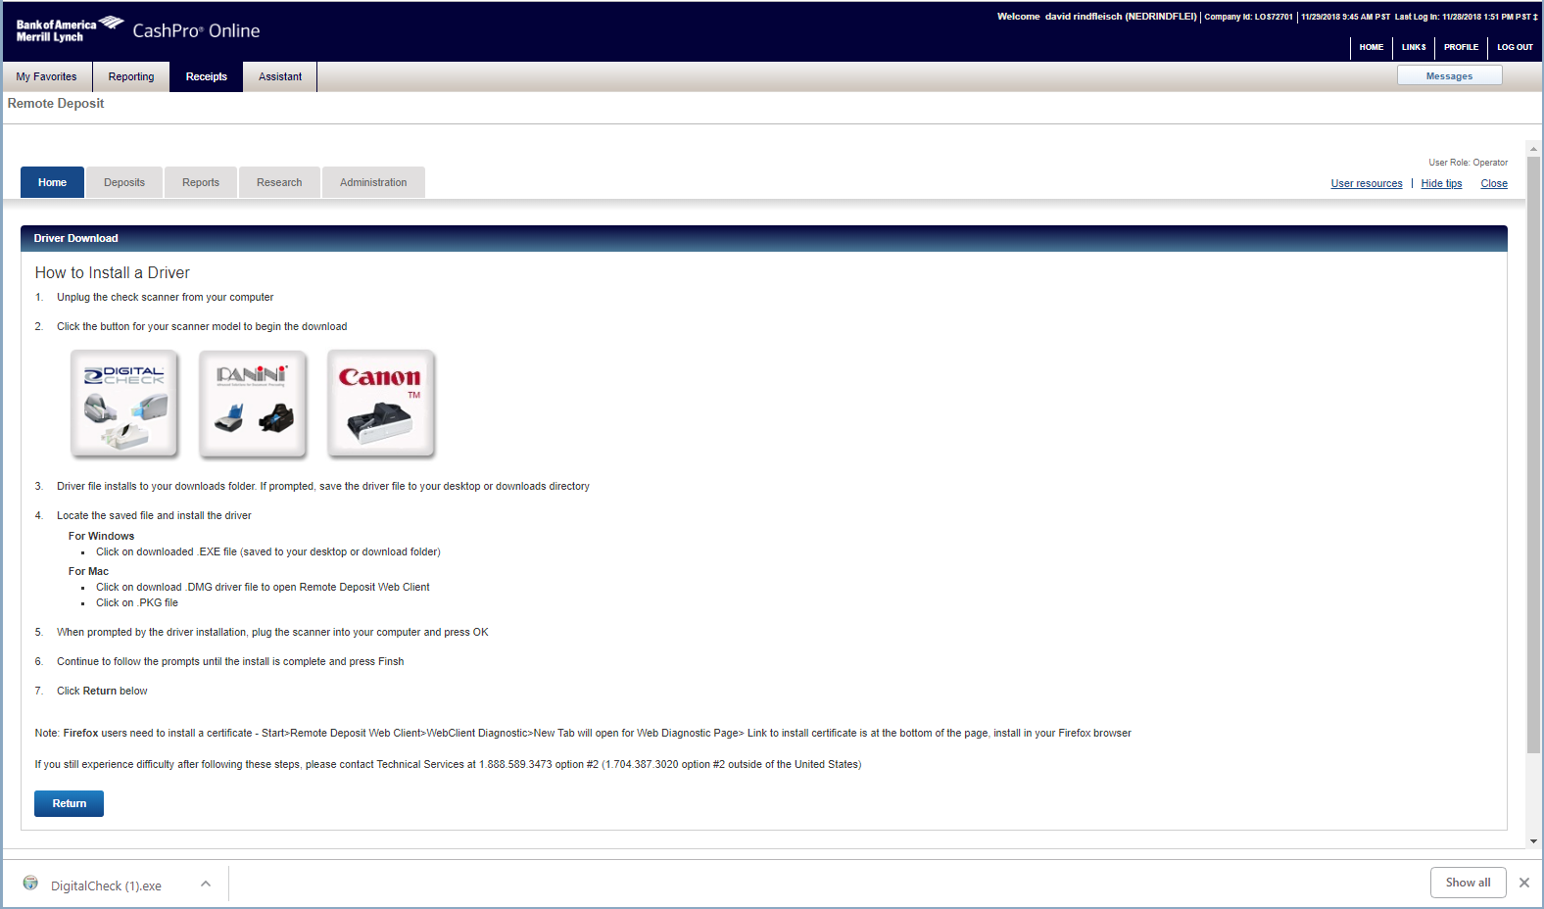

1. When asked if you would like this program to make changes to the computer click OK
2. Next a pop-up asking you to unplug the printer will appear.
3. Unplug the scanner from the computer and click OK

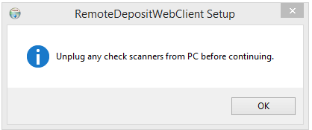

1. The set up program will now launch click “OK” on the first screen and “Install” on the next screen

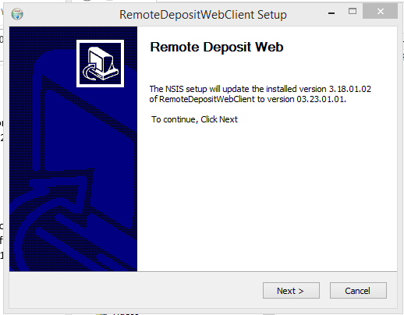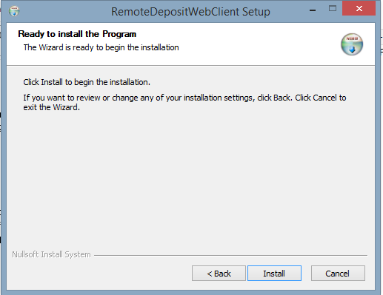

1. The installation will begin. After a moment, you will be prompted to plug back in the printer. Do so and click OK

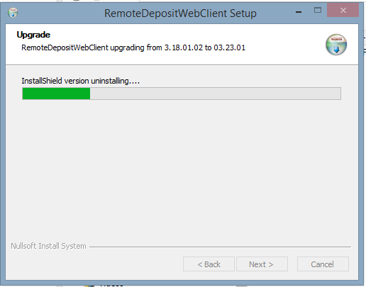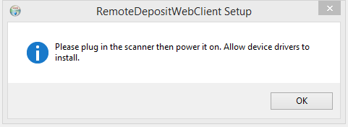

1. The following confirmation screen should appear with all the lines status’ set to “Pass” like the screen shot below. Click “Next >”

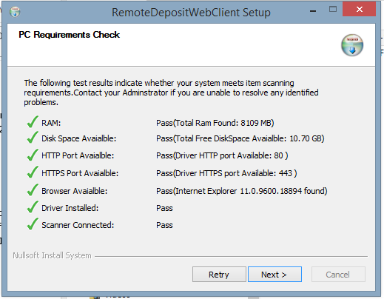

1. Click “Finish” on the last screen. The scanner should now have a green light on and be in working order.

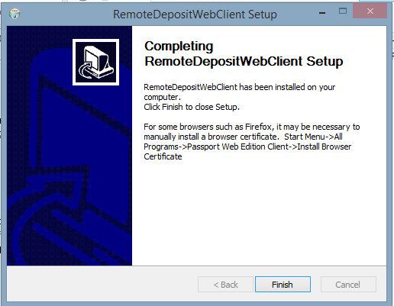

Plug scanner into other computer

If the scanner is the problem, there is a back-up scanner under the computer.